**Branching:**

1. Create a new branch **“GitNewBranch”.**

1. List all the local and remote branches available in the current trunk. Observe the “*” mark which denote the current pointing branch.

1. Switch to the newly created branch. Add some files to it with some contents.

1. Commit the changes to the branch.

1. Check the status with **“git status”** command.

**Merging:**

1. Switch to the master

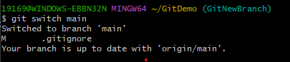

1. List out all the differences between trunk and branch. These provide the differences in command line interface.

1. List out all the visual differences between master and branch using **P4Merge tool**.

• Left side → file from main

• Right side → file from GitNewBranch

1. Merge the source branch to the trunk.

1. Observe the logging after merging using **“git log –oneline –graph –decorate”**

1. Delete the branch after merging with the trunk and observe the git status.

